**[How to Clear Your Computer’s CMOS to Reset BIOS Settings](http://www.howtogeek.com/131623/how-to-clear-your-computers-cmos-to-reset-bios-settings/" \o "How to Clear Your Computer’s CMOS to Reset BIOS Settings)**

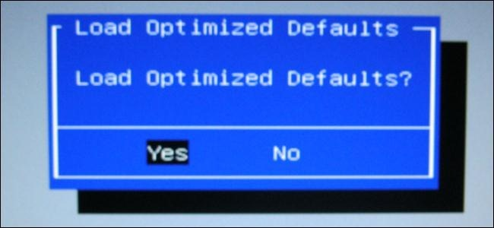

Your computer stores low-level settings like the system time and hardware settings in its CMOS. These settings are configured in the BIOS setup menu. If you’re experiencing a hardware compatibility issue or another problem, you may want to try clearing the CMOS.

Clearing the CMOS resets your BIOS settings back to their factory default state. In most cases, you can clear the CMOS from within the BIOS menu. In some cases, you may have to open your computer’s case.

Use the BIOS Menu

The easiest way to clear the CMOS is from your computer’s BIOS setup menu. To access the setup menu, restart your computer and press the key that appears on your screen – often Delete or F2 – to access the setup menu.

If you don’t see a key displayed on your screen, consult your computer’s manual. Different computers use different keys. (If you built your own computer, consult your motherboard’s manual instead.)

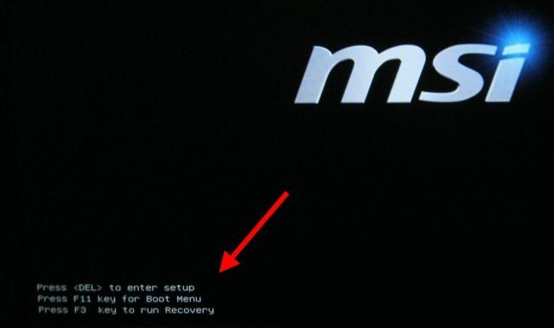

Within the BIOS, look for the Reset option. It may be named *Reset to default, Load factory defaults, Clear BIOS settings, Load setup defaults*, or something similar.

Select it with your arrow keys, press Enter, and confirm the operation. Your BIOS will now use its default settings – if you’ve changed any BIOS settings in the past, you’ll have to change them again.

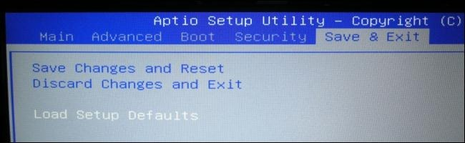

Use the CLEAR CMOS Motherboard Jumper

Many motherboards contain a jumper that can be used to clear CMOS settings if your BIOS is not accessible. This is particularly useful if the BIOS is password-protected and you don’t know the password.

The exact location of the jumper can be found in the motherboard’s (or computer’s) manual. You should consult the manual for more detailed instructions if you want to use the motherboard jumper.

However, the basic process is fairly similar on all computers. Flip the computer’s power switch to off to ensure it’s not receiving any power. Open the computer’s case and locate the jumper named something like CLEAR CMOS, CLEAR, CLR CMOS, PASSWORD, or CLR PWD – it will often be near the CMOS battery mentioned below. Ensure you’re grounded so you don’t damage your motherboard with static electricity before touching it. Set the jumper to the “clear” position, power on your computer, turn it off again, set the jumper to the original position – and you’re done.

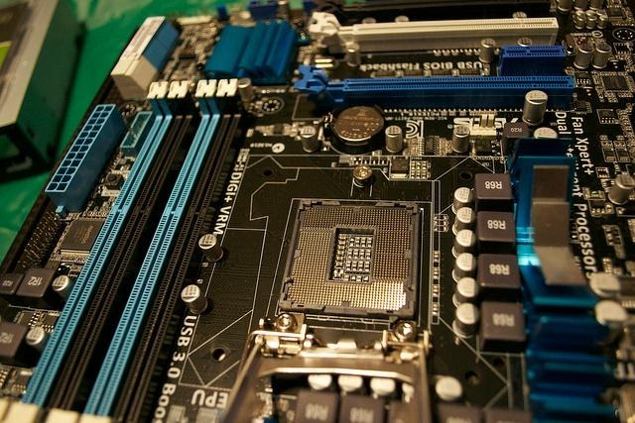

Image Credit: [Eden Richardson](http://www.flickr.com/photos/edenalobservature/8080802540/)

Reseat the CMOS Battery

If your motherboard does not have a CLEAR CMOS jumper, you can often clear its CMOS settings by removing the CMOS battery and replacing it. The CMOS battery provides power used to save the BIOS settings – this is how your computer knows how much time has passed even when it’s been powered-off for a while – so removing the battery will remove the source of power and clear the settings.

**Important Note**: Not all motherboards have removable CMOS batteries. If the battery won’t come loose, don’t force it.

First, ensure the computer is powered off and you’re grounded so you won’t damage the motherboard with static electricity. Locate the round, flat, silver battery on the motherboard and carefully remove it. Wait five minutes before reseating the battery.

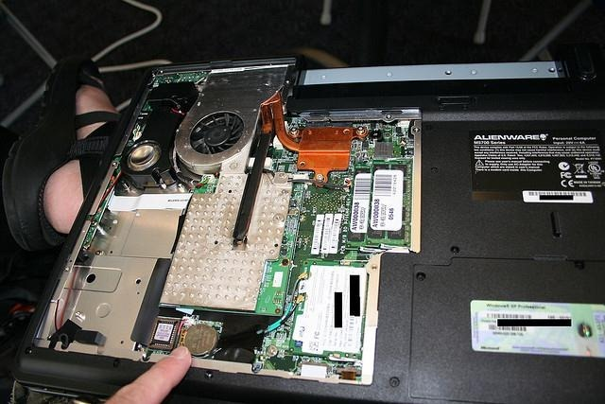

Image Credit: [John Lester](http://www.flickr.com/photos/pathfinderlinden/214700886/)

Clearing the CMOS should always be performed for a reason – such as troubleshooting a computer problem or clearing a forgotten BIOS password. There’s no reason to clear your CMOS if everything is working properly.